**Scholars Journal of Applied Medical Sciences**  

Abbreviated Key Title: Sch J App Med Sci

**Surgery**

ISSN 2347-954X (Print) | ISSN 2320-6691 (Online)

Journal homepage: <https://saspublishers.com/journal/sjams/home>

**A Prospective Study of Iatrogenic Ureteric Injury in a Tertiary Referral Center**

Dr. Ahmad Faraz Danish1, Dr. Souvik Basak2*, Dr. Krishnendu Maiti3, Prof. (Dr.) Kashinath Das4

1Senior Resident, Department of Burns, Plastic Maxillofacial Surgery, VMMC & Safdarjung Hospital, Delhi, India

2Assistant Professor, Department of Surgery, Medical College, Kolkata, India

3Assistant professor, Department of urology, IPGMER & SSKM Hospital Kolkata, India

4Ex- (Professor and Head), Department of Surgery, Medical College, Kolkata, India

**\*Corresponding author:** Dr. Souvik Basak | **Received:** 15.01.2019 | **Accepted:** 26.01.2019 | **Published:** 30.01.2019

**DOI:** 10.36347/sjams.2019.v07i01.059

|  |  |  |
| --- | --- | --- |
| **Abstract** |  | **Original Research Article** |

|  |
| --- |
| The incidence of iatrogenic ureteric injuries varies from 0.5–10% in different studies. This study was designed to describe our experiences in the presentation, detection, management and outcome of iatrogenic ureteric injuries. It was seen that mean age of presentation was 38 years with clear female preponderance (M:F = 1:8). Hysterectomy was most common aetiology affecting almost 56% of patients. About 56% of patients were diagnosed after 7 days of primary surgery. Left side ureter was affected more (50%) with almost 78% involvement of lower third of ureter. Suture ligation and ureteric transection was found as most common cause of injury in this study. Ureteroneocystostomy was most commonly performed procedure for repair. Our experience in this study shows that iatrogenic ureteric injuries are still common in our environment and total abdominal hysterectomy accounts for most cases. Most of the injuries are a result of complications of abdominopelvic operations in the peripheral hospitals. Meticulous surgical technique along with identification of the course of the ureter and associated anatomic locations where injury is most likely to occur is important to decrease the risk of ureteric injury. Early recognition and prompt repair of ureteric injuries is the key to a successful outcome.  **Keywords:** Aetiological factor Iatrogenic, Incidence, Treatment outcome, Ureteric injuries. |

**Copyright © 2019:** This is an open-access article distributed under the terms of the Creative Commons Attribution license which permits unrestricted use, distribution, and reproduction in any medium for non-commercial use (NonCommercial, or CC-BY-NC) provided the original author and source are credited.

**INTRODUCTION**

Injury to the ureter is one of the most serious complications of any abdominal or pelvic procedure whether from gynaecological, urological or general surgical disease and the medico-legal implication has always been a major area of concern [1]. These complications can result in high morbidity and even mortality for the patients, which can create anxiety and psychosocial concerns for the patients and their spouses.

The incidence of iatrogenic ureteric injuries varies from 0.5–10% in different studies [2,3]. It can occur during any difficult abdominopelvic surgery. Obstetric and gynaecological surgery, vascular surgery, general surgical procedures especially colorectal surgery and urological procedures are commonly responsible for ureteric injuries [4]. Endourological procedures also account for many ureteric injuries [5].

Traditionally, gynaecological procedures have been reported to account for between 50 and 75% of iatrogenic ureteric injuries (IUI) since the ureter lies near the female reproductive organs throughout its course from the pelvic brim to the bladder. Gynaecological or pelvic disease can involve the ureter directly or can cause the course of the ureter to deviate. The normal anatomic relations of the ureter in the pelvis can also vary, thereby making it vulnerable to injury [6-9]. Inexperience of the operating surgeon is also a risk factor for ureteric injury.

During abdominopelvic surgery, ureteric injury may be in the form of crushing injury by a clamp, inadvertent diathermy injury, suture ligation, transaction, resection of a segment of ureter, kinking of ureter, and devascularisation of a segment of ureter due to extensive dissection close to ureter. Patient may develop urinary fistula with adjacent organ or end up with non-functioning kidney later on [10].

Diagnosis of iatrogenic ureteral injury is often delayed. Thus, the clinician must maintain a high index of suspicion for ureteral injury and assess for signs in the postoperative period, such as abdominal pain, tenderness, and fever. The management of iatrogenic ureteric injuries in our environment poses major challenges to urologist practicing in east India where most ureteric injuries after abdominopelvic surgeries are diagnosed late postoperatively with fever, loin pain, per-vaginal urine leak, prolonged ileus, oliguria, anuria and uremic symptoms. Some patients may remain asymptomatic and present years later with hydro-nephrotic, non-functioning kidney on investigations [11].

This study was designed to describe our experiences in the presentation, detection, management and outcome of iatrogenic ureteric injuries, highlighting the causes, clinical presentation and treatment outcome of iatrogenic ureteric injuries in Medical College & Hospital Kolkata.

**MATERIAL AND METHODS**

This was an institution-based, prospective study conducted in Department of Surgery, Medical College, Kolkata, India from January 2014 - June 2015 (18 months). Informed consent was taken from all the patients. The study got clearance from Institutional Ethical Committee. Sample size was 20.

Inclusion Criteria: The following patients were included in the study population:

* All postoperative ureteric injuries which will be referred to Dept. of General Surgery or Urology unit, Medical College Kolkata, during study period which will be treated either by stenting or operative intervention.

Exclusion Criteria: The following patients were excluded from the study population:

* Those ureteric injuries which were operated upon outside either by stenting or operative intervention (redo-ureteric injury) are excluded. Patients who have already received neoadjuvant chemotherapy.
* Non-iatrogenic traumatic ureteric injury (stab injury or blunt trauma, gunshot injury).

Those ureteric injuries that will be identified during operation apart from clinical confirmation of ureteric injury, no other investigation will be done and will be repaired in same sitting. Suspected intraoperative ureteric injuries will be further investigated with bladder distension with methylene blue and normal saline mixture for any extravasation. In some rare instances I.V. indigo carmine will be given for identification of ureteric injury. Those patients who will be detected postoperative should be investigated with complete hemogram, urine routine examination, microscopic examination, culture and antibiotic sensitivity testing, ascitic fluid creatinine level. Blood urea, serum creatinine ultrasonography of whole abdomen, CECT (Contrast enhanced Computerized Tomography) whole abdomen, IVU (Intravenous urography) in selected cases. Depending upon the situation abdominal drain will be put to drain urinary ascites and/or percutaneous nephrostomy will be done in grossly hydronephrotic renal unit. Definitive ureteric reconstruction will be done subsequently after optimization of patient’s condition. Patient will be followed up for six months with renal function, USG abdomen and IVU.

**RESULTS**

In this study 18 patients were studied prospectively.

**Descriptive Statistics**

**Age**

Mean age was 37.61 years with range of 21 – 56 years

**Table-1: Descriptive Statistics of Age**

|  |  |  |
| --- | --- | --- |
| Age Groups (Years) | Frequency | Percentage (%) |
| </= 40 YEARS | 12 | 12 |
| > 40 YEARS | 6 | 6 |

**Sex Distribution**

**Table-2: Descriptive Statistics of Sex**

|  |  |  |
| --- | --- | --- |
| Sex | Frequency | Percentage (%) |
| Male | 2 | 11.11 |
| Female | 16 | 88.89 |

**Nature of Surgery**

**Table-3: Descriptive Statistics of Nature of Surgery**

|  |  |  |
| --- | --- | --- |
| Nature of surgery | Frequency | Percentage (%) |
| Elective | 14 | 77.78 |
| Emergency | 4 | 22.22 |

**Etiology**

Out of 18 patients, 10 underwent abdominal hysterectomy, 2 underwent vaginal hysterectomy and rest underwent operations like left colectomy, RPS (Retroperitoneal sarcoma) excision, LUCS (Lower uterine caesarean section) etc.

**Table-4: Descriptive Statistics of Etiology of Iatrogenic Ureteric injury**

|  |  |  |
| --- | --- | --- |
| Etiology | Frequency | Percentage (%) |
| Abdominal hysterectomy (lap + Open) | 10 | 55.56 |
| Vaginal hysterectomy (VH) | 2 | 11.11 |
| Left colectomy | 1 | 5.56 |
| RPS excision | 1 | 5.56 |
| IATE (Intra-abdominal tumor excision) | 1 | 5.56 |
| LUCS | 3 | 16.67 |

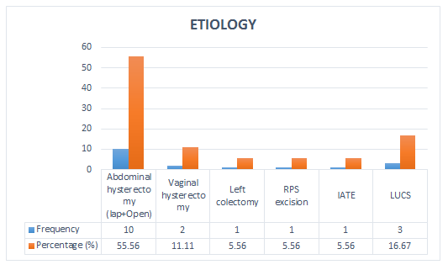

**Chart-1: Bar diagram for Etiology of Iatrogenic Ureteric injury.**

**Nature of etiology**

Of the 18 cases, 12 were operations for benign diseases and 6 for malignant diseases (Table-5).

**Time interval**

Time interval from the day of surgery to onset of clinical features of ureteral injury was calculated (Table-6).

**Table-5: Descriptive Statistics of Nature of Etiology**

|  |  |  |
| --- | --- | --- |
| Benign/malignant | Frequency | Percentage (%) |
| Benign | 12 | 66.67 |
| Malignant | 6 | 33.33 |

**Table-6: Descriptive Statistics of Time Interval**

|  |  |  |  |  |
| --- | --- | --- | --- | --- |
|  | N | Minimum | maximum | Mean |
| Time interval (in days) | 18 | 2 | 123 | 14.27 |

**Table-7: Descriptive Statistics of Time Interval**

|  |  |  |
| --- | --- | --- |
| Time Interval | Frequency | Percentage (%) |
| </= 7 days | 8 | 44.44 |
| > 7 days | 10 | 55.56 |

**Laterality of injured ureter**

**Table-8: Descriptive Statistics of Laterality of injured ureter**

|  |  |  |
| --- | --- | --- |
| Laterality | Frequency | Percentage (%) |
| Right | 7 | 38.89 |
| Left | 9 | 50.00 |
| Both | 2 | 11.11 |

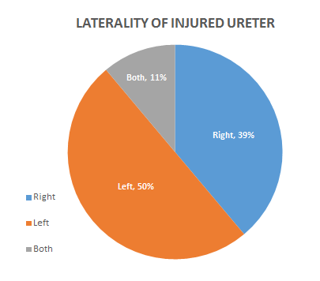

**Chart-2: Pie Chart showing distribution of Laterality of injured ureter**

**Site of injury**

**Table-9: Descriptive Statistics of Site of injured ureter**

|  |  |  |
| --- | --- | --- |
| Part of ureter injured (upper/middle/lower) | Frequency | Percentage (%) |
| Upper 1/3 | 1 | 5.56 |
| Middle 1/3 | 3 | 16.67 |
| Lower 1/3 | 14 | 77.78 |

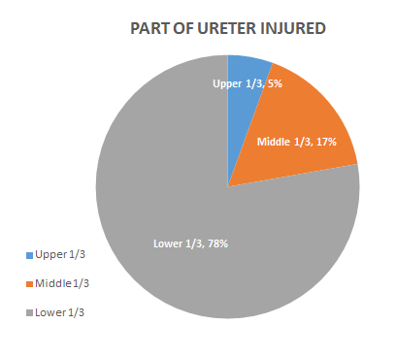

**Chart-3: Pie Chart showing distribution of Site of injured ureter**

**Mode of Presentation**

There were various clinical features following iatrogenic ureteral injury (Table-10).

**Modes/Types of injury**

There were various modes of iatrogenic injury including suture ligation, transection with or without loss of segment and UV fistula (Table-10).

**Table-10: Descriptive Statistics of clinical features following iatrogenic ureteral injury**

|  |  |  |
| --- | --- | --- |
| Features | Frequency | Percentage (%) |
| Triad of abdominal distension, vomiting, fever | 4 | 22.22 |
| Abdominal distension | 7 | 38.89 |
| Vaginal leakage | 3 | 16.67 |
| Urine in drain | 2 | 11.11 |
| Wound leakage | 1 | 5.56 |
| Anuria | 2 | 11.11 |
| Flank pain | 1 | 5.56 |
| Non-functional kidney | 1 | 5.56 |
| Pyuria+ azotemia | 1 | 5.56 |

**Table-11: Descriptive Statistics of various types of injury**

|  |  |  |
| --- | --- | --- |
| Modes/types of Injury | Frequency | Percentage (%) |
| Suture ligation | 5 | 27.78 |
| Ureteric transaction | 9 | 50.00 |
| Ureterovaginal fistula | 3 | 16.67 |
| Ureteric transection with loss of segment | 1 | 5.56 |

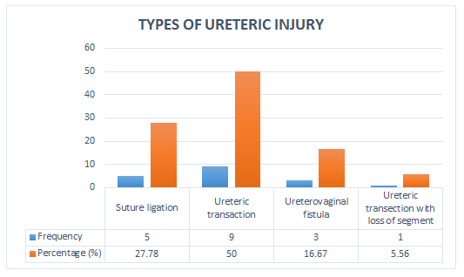

**Chart-4: Bar diagram showing distribution of types of ureteric injury**

**Treatment**

Out of total 18 patients 7 (38.89%) underwent primary repair of ureteric injury, whereas 9 patients (50%) underwent staged procedures, including pigtail drainage of ascites, PCN, open pyelostomy, and abdominal drain placement.

**Table-12: Distribution of planning of treatment**

|  |  |  |
| --- | --- | --- |
| Planning of Treatment | Frequency | Percentage (%) |
| Primary repair | 7 | 38.89 |
| Staged Procedure | 9 | 50.00 |
| Observation | 2 | 11.11 |

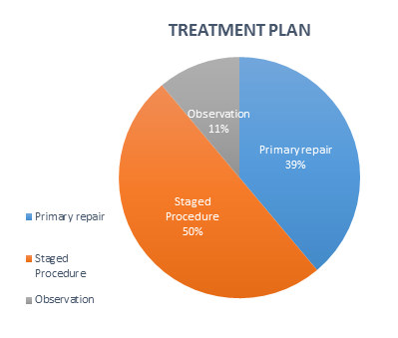

**Chart-5: Pie Chart showing treatment planning for injured ureter**

**Table-13: Distribution of initial measures in staged procedures\***

|  |  |  |
| --- | --- | --- |
| Initial measures in staged Procedures | Frequency | Percentage (%) |
| Abdominal drain placement | 4 | 44.44 |
| Pigtail drainage of ascites | 2 | 22.22 |
| PCN# | 1 | 11.11 |
| Open pyelostomy | 2 | 22.22 |

* These all 9 patients underwent definitive surgical procedures for ureteral injury repair. DJ stent was placed in all patients during operation which was removed after 4-6 weeks following surgery.

# PCN-percutaneous nephrostomy

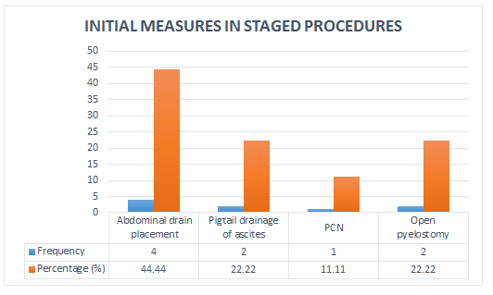

**Chart-6: Bar Diagram showing initial measures in staged procedures**

**Table-14: Distribution of types of ureteric injury repair**

|  |  |  |
| --- | --- | --- |
| Types of ureteric injury repair | Frequency | Percentage (%) |
| End to end ureteroureterostomy | 2 | 12.5 |
| Ureteroneocystostomy | 7 | 43.75 |
| Ureteroneocystostomy with PBH* | 4 | 25 |
| Ureteroneocystostomy with PBH* with pyeloureterostomy | 1 | 6.25 |
| Nephrectomy | 2 | 12.5 |

*PBH- psoas bladder hitch



**Chart-7: Bar Diagram showing types of ureteric injury repair**

**Length of hospital stay**

**Table-15: Distribution of length of hospital stays in days**

|  |  |  |  |  |
| --- | --- | --- | --- | --- |
|  | N | Minimum | Maximum | Mean |
| Hospital stay (in days) | 18 | 9 | 63 | 21.38 |

Range-: 9 - 63 days

**Post-operative complication**

Out of total 16 operated patients 6 patients (37.5%) had post-operative complications.

Pyrexia and UTI were treated with over the counter drugs.

SSI (superficial) was treated with daily wound dressing, debridement and secondary suturing.

USG guided drainage of intra-abdominal abscess was done along with antibiotics.

**Table-16: Distribution of various post-operative complications**

|  |  |  |
| --- | --- | --- |
| Complications | Frequency | Percentage (%) |
| Post-operative pyrexia | 2 | 33.33 |
| Urinary tract infection | 2 | 33.33 |
| Surgical site infection | 1 | 16.67 |
| Intra-abdominal abscess | 1 | 16.67 |

**Follow up**

Patients were followed up to the mean duration 9.4 months. They were followed up with physical examination, blood investigation for urea /creatinine, USG and IVU.

**Table-17: Descriptive Statistics of follow up duration**

|  |  |  |  |  |
| --- | --- | --- | --- | --- |
|  | N | Minimum | Maximum | Mean |
| Duration (in months) | 18 | 2 | 16 | 9.4 |

**DISCUSSION**

In this study 18 patients with iatrogenic ureteral injury, occurred either in medical college Kolkata (n=4) or referred from other centres (n=14) were diagnosed, and managed with further follow up. Exact incidence of iatrogenic ureteral injury cannot be calculated in this study population as 14 patients were referred to Medical College, Kolkata from different medical centres and total number of operations done in these centres were unknown. High incidence of ureteric injuries among patients who had abdominopelvic operations were performed in peripheral hospitals.

In our study the mean age of study population was 37.61 years. Maximum no. of cases i.e. 6 cases (33.33%) were in the age group of 31-35 years. Overall 12 cases (66.67) were in </= 40 years age group. In one study mean age of injury was 40 years [14]. 10 years’ experience in a tertiary care hospital regarding iatrogenic injury in Tanzania also states “The age of patients at presentation ranged from 24 to 74 years with a median age of 36 years. The peak age incidence was in the age group 31–40 years” [13].

In this study, out of 18 patients 2 (11.11%) were male and 16 (88.89%) were female patients. According to an older series with 87 cases of iatrogenic ureteral injuries, 81% were male and 19% were female, which is consistent with this study as well. Out of total 18 cases 14 (77.78%) were operated as on elective basis and 4 cases (22.22%) were on emergency basis. In this study gynaecological surgeries were the most common cause of ureteral injury (16 cases, 88.89%). The anatomical proximity of the female urinary and genital tracts makes injury to the ureters a constant threat during gynaecological surgery as ureteral injuries may be almost unavoidable in some situations even in the hands of the most skilled and experienced gynaecological surgeons [7].

Abdominal hysterectomy was the most common cause of ureteral injury which comprises 55.56% of total. Second most common cause was lower segment caesarean section with 16.67% contribution to total aetiology. Vaginal hysterectomy being the third common cause comprises 11.11%, remaining causes were left colectomy, intra-abdominal tumour excision and retroperitoneal sarcoma excision with 5.56% each. According to literature, hysterectomy is the most common cause of ureteral injury (54%) [12] as in this study. Caesarean section is the second most common cause (18.6%) [14].

12 cases (66.67%) were operated for benign and only 6 cases (33.33%) for malignant cause. This can be explained by the over cautious attitude of the surgeons while operating on malignant cases and thus less injuries following operations for benign causes. But with this small sample size this cannot be interpreted for all population with ureteral injuries. All cases were diagnosed in post-operative period. Time interval from the day of surgery to diagnosis was 2-123 days with mean of 14.27 days. 8 cases (44.44%) were diagnosed within 7 days of surgery but 10 cases (55.56%) were diagnosed after 7 days of surgery. According to literature time interval from surgery to diagnosis ranges between 2-186 days with mean of 10 days.

In this study out of 18 cases 9 (50%) had injury on left ureter while 7 cases (38.89%) had injury on right ureter and 2 cases (11.11%) had injury on both ureters. Left to right ratio was 1.28:1. In literature 59.8% patients had left sided ureteric injuries and 36.6% had right sided ureteric injuries with a left to right ratio of 2.1: 1. 20.4% patients had bilateral ureteric injuries [13]. The left ureter has a greater proximity to the cervix compared to the right ureter, and is thus more liable to injury [16].

After proper evaluation of patients and radiological investigations (CECT abdomen, retrograde urogram, IVU) it was found that lower third of the ureter is most common site of injury (77.78%). Involvement of middle third in 3 cases (16.67%) and upper third in 1 case only (5.56%). This is in contrast to the close proximity of the lower third of ureter with uterine artery. Distal ureter was most commonly injured in 34 cases (79%) in one study [14] which is almost similar to our study.

All patients were diagnosed in post-operative period. The triad of abdominal distension, vomiting and fever was present in 4 cases (22.22%). Abdominal distension was the most common mode of presentation (38.39% of cases). Other presentations were vaginal leakage in 3 cases (16.67%); urine in drain and anuria was in 2 cases (11.11%) each; wound leakage, flank pain, non-functional kidney and pyuria with azotemia in one case (5.56%) each. In previous studies and literature there is no correlation between the modes of presentation. All studies showed different patterns of presentation.

Ureter was injured intraoperatively by different mechanisms, out of which ureteric transection was the most common (n = 9.50%); suture ligation in 5 cases (27.78%); ureterovaginal fistula in 3 cases (16.67%) and ureteric transection with loss of segment in one case (5.56%). The true incidence of ligation injury may never be known because a unilateral ureteric ligation can easily be missed as the affected kidney may undergo silent atrophy in the presence of a normal contralateral kidney. An incidental clinical or radiological diagnosis of hydro nephrosis usually brings attention to such cases [15]. Same as in this study where incidental diagnosis was made in one patient after 123 days of primary surgery by ultrasonography of abdomen.

Two patients (11.11%), one who was operated for retroperitoneal sarcoma and another for intra-abdominal tumour, were observed continuously during post-operative period. These two patients became asymptomatic after few days. Later on, it was found that both patients had unilateral non-functional kidney. Both these patients refused for further management. Other 16 patients underwent surgical treatment. 7 patients (38.89%) underwent primary repair of the injury and 9 patients (50%) underwent staged procedures after proper optimization. Abdominal drain placement in 4 cases (44.44%), pigtail drainage of ascites in 2 cases (22.22%), PCN in 1 case (11.11%) and open pyelostomy in 2 cases (22.22%) as an initial procedure for the patients who ultimately underwent definitive procedures.

In total 16 patients who underwent surgical treatment, ureteroneocystostomy was most commonly performed surgery (n=7, 43.75%). Ureteroneocystostomy with psoas bladder hitch was done in 4 cases (25%); end to end ureterureterostomy in 2 cases (12.5%); nephrectomy in 2 cases (12.5%); and ureteroneocystostomy along with psoas bladder hitch and ureterureterostomy was performed in 1 case (6.25%). According to literature Ureteroneocystostomy was the most frequent reconstructive surgery performed in 58.0% of cases [13]. In another study they performed PCN in 32.5% of the cases following diagnosis [14] but due to non-availability of required infrastructure for PCN in our centre we have managed these cases by open pyelostomy and abdominal drain placement without any mortality. The overall length of hospital stays ranged from 9 days to 63 days with mean of 21.38 days.

In one study the hospital stays of patients ranged on the average from 14 to 35 days [15]. In another study the overall length of hospital stays ranged from 1 day to 75 days with a median of 12 days [13]. Delayed diagnosis, post-operative complications and a greater number of patients who stayed in hospital up to the definitive surgical measures taken to repair the ureteral injury probably explains this longer stay in hospital.

We have followed up these patients up to mean duration of 9.4 months (range from 2-16 months). All patients did well after surgery without any mortality accept 6 patients (37.5% of n=16) who had post-operative complications like SSI, UTI, fever, and intra-abdominal abscess which were managed accordingly. No post-operative ureteral obstruction in any patients has been seen so far. Follow up IVU shows normal flow of urine from ureter to bladder without any obstruction or narrowing of the anastomotic sites. Post-operative complications following repair of iatrogenic ureteral injury has not been mentioned clearly in many studies. In one study postoperative complications were recorded in 18.5% patients, the commonest being surgical site infections in 36.8% of patients which is far less than our study [13].

**CONCLUSION**

Mean age of the patients with iatrogenic ureteral injury was 38 years with most frequently affected age group of 31-35 years.Females were more affected than males (M:F = 1:8). Abdominopelvic surgeries should be done with utmost care in females because of their incidence of more involvement and close proximity of ureter with the uterine artery.Hysterectomy was most common etiology for ureteral injury affecting almost 56% of patients.In 67% of patients’ pathology was benign. 78% got injury following elective surgery. So preoperative assessment and preventive measures like ureteral stenting, can be taken in elective cases to prevent and early intraoperative detection.

About 56% of patients were diagnosed after 7 days of primary surgery. Left side ureter was affected more (50%) with almost 78% involvement of lower third of ureter. If the triad of post-operative abdominal distension, fever and vomiting after pelvic surgeries is present then ureteral injury must be suspected and ruled out. As suture ligation and ureteric transection was most common cause of injury in this study, we must be careful while using diathermy deep in pelvis or ligating any tubular structure. Abdominal drain placement, pigtail drainage of ascites, and open pyelostomy is fair options to relieve the symptoms of ureteral injury in centres where there is no facility for PCN available.

Ureteroneocystostomy was most commonly performed procedures. Our experience in this study shows that iatrogenic ureteric injuries are still common in our environment and total abdominal hysterectomy accounts for most cases. Most of the injuries are a result of complications of abdominopelvic operations in the peripheral hospitals. Meticulous surgical technique along with identification of the course of the ureter and associated anatomic locations where injury is most likely to occur is important to decrease the risk of ureteric injury. Early recognition and prompt repair of ureteric injuries is the key to a successful outcome.

**REFERENCES**

1. Preston JM. Iatrogenic Ureteric Injury: Common Medicolegal Pitfalls, BJU International. 2001; 86: 313- 317.
2. Fraga GP, Borges GM, Mantovani M, Ferreira U, Laurito TL, Netto NR Jr. Penetrating ureteral trauma. Int Braz J Urol. 2007; 33:142–50.
3. Al-Awadi K, Kehinde EO, Al-Hunayan A, Al-Khayat A. Iatrogenic ureteric injuries: incidence, aetiological factors and the effect of early management on subsequent outcome. Int Urol Nephrol. 2005; 37:235–41.
4. Ahn M, Loughlin KR. Psoas hitch ureteral reimplantationin adults - analysis of a modified technique and timing of repair. Urology. 2001; 58: 184-
5. Geavlete P, Georgescu D, Niţă G, Mirciulescu V, Cauni V. Complications of 2735 retrograde semirigid ureteroscopy procedures: a single-center experience. J Endourol. 2006; 20:179–85.
6. Thompson JD. Operative injuries to the ureter: prevention, recognition, and management. Te Linde's operative gynecology. 1997; 8:1135-73.
7. Aronson MP and Bose TM. Urinary Tract Injury in Pelvic Surgery. Clin. Obst. And Gynae. 2002; 45: 428-438
8. Paivi H, Jare S and Aila T. Urinary Tract Injuries after Hysterectomy. Obst. And Gynae. 1998; 92.
9. Rosemarie Fröber. Surgical Atlas, Surgical Anatomy of the Ureter, 2007 BJU International. 100: 949-965.
10. Schimpf MO, Gottenger EE, Wagner JR. Universal ureteral stent placement at hysterectomy to identify ureteral injury: a decision analysis. BJOG 2008; 115:1151–8.
11. Chinakwana GU, Okafor PI, Ikechebelu JI. Urology injuries following gynaecological operation–our experience in a teaching hospital in Nigeria. West Afr J Med. 2006; 25:153–6.
12. Campbell-walsh Urology; 10th Edition
13. Chalya PL, Massinde AN, Kihunrwa A, Simbila S. Iatrogenic ureteric injuries following abdomino-pelvic operations: a 10-year tertiary care hospital experience in Tanzania. World Journal of Emergency Surgery. 2015 Dec;10(1):17.
14. Saadia Nawaz Durrani, Ata ur Rehman, Sarhad Khan, Hazrat Ullah, Muhammad Kamran Khan, Anayat ullah. Ureteral trauma during open surgery: aetiology, presentation and management. J Ayub Med Coll Abbottabad. 2013;25(3-4)
15. Tijani KH, Onwuzurigbo KI, Ojewola RW, Afolabi BB, Akanmu NO. Iatrogenic ureteric injuries in a Nigerian teaching hospital: experience in the last decade. East Afr Med J. 2011; 88:304–9.
16. Fröber R. Surgical atlas, surgical anatomy of the ureter. BJU Int. 2007; 100:949–65.